Galloping Horse

The first task:

- Take a piece of 2mm graph paper. Draw a pair of axes with x from –6 to 4, and y from –3 to 3. The scale is 2cm to 1 unit.
- Plot each section in turn, joining the points within the section with a faint curved line as you go.

Section One
(-5,0)
(-4,0.3)
(-3,1)
(-2,1.3)
(-1,1.1)
(-0.5,0.9)
(0,1)
(1,1.5)
(1.5,1.8)
(2.3,2.2)

Section Two
(2.6,2)
(2.4,2.1)
(2.2,2.5)
(2.6,2.3)
(2.7,2.1)

Section Three
(2.6,2.3)
(2.5,2.6)
(2.8,2.2)
(3,2)
(3.2,1.7)
(3.4,1.2)
(3.7,0.8)
(3.5,0.5)
(3.2,0.6)
(2.7,1)
(2.3,1.2)
(2.3,1.6)

Section Four
(2.3,1.2)
(2,1)
(1.8,0)
(1.7,-0.5)

Section Five
(1.5,-0.2)
(1.8,-1)
(2.3,-1.6)
(2.6,-2)
(3,-2.3)
(3.2,-2.6)
(3.5,-3)
(3.1,-2.9)
(3,-2.7)
(2.3,-1.9)
(2,-1.8)
(1.4,-1.1)
(1,-0.7)
(0,-0.9)
(-1.4,-0.5)
(-1.8,-0.3)

Section Six
(-1.4,-0.5)
(-1.2,-1.6)
(-0.5,-2.3)
(0,-2.6)
(-0.5,-2.7)
(-0.5,-2.5)
(-0.9,-2.3)
(-1.2,-1.9)
(-1.8,-1.5)
(-2.2,-0.8)

Section Seven
(-2,0.7)
(-1.7,0)
(-1.8,-0.3)
(-2.2,-0.8)
(-3,-1.5)
(-2.9,-2)
(-2.5,-2.8)
(-2.3,-3)
(-2.7,-3)
(-2.8,-2.8)
(-3,-2.5)
(-3.3,-1.6)
(-3.5,-1.3)
(-3,-0.5)
(-3.3,0)
(-3.4,0.3)
(-3.2,0.6)
(-3.7,0)
(-4.3,-0.2)
(-5,-0.5)
(-5.3,-0.7)
(-5.2,-0.5)
(-5.5,-0.7)
(-5,0)

Section Eight
(3,1.6)

Section Nine
(1.8,0)
(2.7,-0.5)
(3,-0.7)
(2.5,-1.5)
(2.4,-1.7)

Section Ten
(2,-1.8)
(1.5,-2.2)
(1.6,-1.8)
(1.9,-1.7)

Section Eleven
(2.2,-1.5)
(2.6,-0.8)
(1.6,-0.5)

The second task:

You are going to create one of your own coordinate pictures. First think what an appropriate type of picture will be. Those with a well defined outline are most successful effective – the fewer lines inside the basic shape, the better. Also, irregular shapes (example animals) are easier. Wheels on a car, for example, are very hard.

- Choose the picture you want to use. Use books to help.
- Trace the shape onto tracing paper. A sharp pencil is essential.
- Use the light table to make a careful copy of this onto graph paper.
- Draw a pair of axes over the top of your outline.
- Decide which sections break up most easily – think back to the horse, and ask for help if you need it.
- Now, carefully go round each section, marking on the important points (these will be where the line is curving, or at definite turns in the line) with a cross. The points can only be marked where your line intercepts a crossing on the graph paper. Again think back to how the horse was drawn.
- Finally you have to carefully read off the coordinates and write them down as a list of instructions.
- Swap your instructions with those of a friend and try each other’s picture. It is best if you swap with someone you have not been working with. That way the picture will be a surprise!
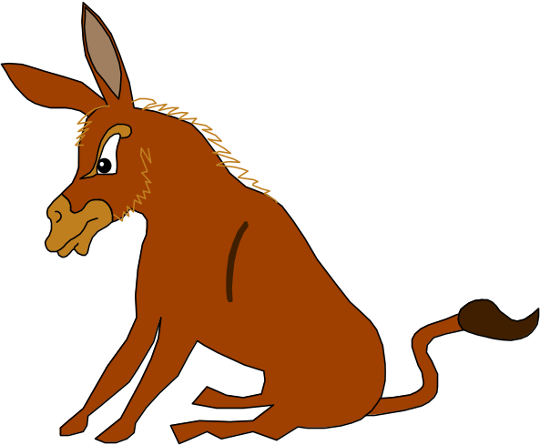

OK so it’s an angry donkey, but I couldn’t find a galloping horse.

